**CHAPTER 1**

**INTRODUCTION**

Image processing is processing of images using mathematical operations by using any form of signal processing for which the input is an image, a series of images, or a video, such as a photographer video frame, the output of image processing may be either an image or a set of characteristics or parameters related to the image. Most image-processing techniques involve treating the image as a two-dimensional signal and applying standard signal-processing techniques to it. Images are also processed as three-dimensional signals where the third-dimension being time or the z-axis. Closely related to image processing are computer graphics and computer vision.

In computer graphics, images are manually *made* from physical models of objects, environments, and lighting, instead of being acquired (via imaging devices such as cameras) from  *natural* scenes, as in most animated movies. Computer vision, on the Other hand, is often considered high*-level* image processing out of which a machine/computer/software intends to decipher the physical contents of an image or a sequence of images

The computer vision based technologies are widely used, however the quality of captured image influence the final effective strongly. In outdoors scenes, some natural elements influence the quality of captured image fig1.1(a). Such as, haze, smoke, fog, rain, snow and other atmosphere factors. In our daily life, haze is the most common problem because of the atmosphere quality.

Haze removal (or dehazing) is highly desired in both consumer/computational photography and computer vision applications. First, removing haze can significantly increase the visibility of the scene and correct the color shift caused by the airlight contrast scene radiance. The haze removal can produce depth information and benefit many vision algorithms and advanced image editing. Haze or fog can be a useful depth clue for scene understanding. The bad haze image can be put to good use.

However, haze removal is a challenging problem because the haze is dependent on the unknown depth information. The problem is under-constrained if the input is only a single haze image. Therefore, many methods have been proposed by using multiple images or additional information. Polarization based methods remove the haze effect through two or more images taken with different degrees of polarization. In more constraints are obtained from multiple images of the same scene under different weather conditions. Depth based methods require the rough depth information either from the user inputs or from known 3D models.

Recently, single image haze removal has made significant progresses. The success of these methods lies in using a stronger prior or assumption. Tan observes that the haze-free image must have higher contrast compared with the input haze image and he removes the haze by maximizing the local contrast of the restored image. The results are visually compelling but may not be physically valid. Fattal estimates the albedo of the scene and then the medium transmission, under the assumption that. So the haze removal technology Fig.1.1(b) needs be studied to recover clear image for satisfying the computer vision applications.



**1.1(a).Hazy image 1.1(b). our result**

**Fig. 1.1. Haze removal using a single image**

Some of the methods used in dehazing the images are:

**1.1 Dark channel**:

The presence of haze in the atmosphere degrades the quality of images captured by visible camera sensors. The removal of haze, called dehazing, is typically performed under the physical degradation model, which necessitates a solution of an ill-posed inverse problem. To relieve the difficulty of the inverse problem, a novel prior called dark channel prior (DCP) was recently proposed and has received a great deal of attention. The DCP is derived from the characteristic of natural outdoor images that the intensity value of at least one color channel within a local window is close to zero. Based on the DCP, the dehazing is accomplished through four major steps: atmospheric light estimation, transmission map estimation, transmission map refinement, and image reconstruction. This four-step dehazing process makes it possible to provide a step-by-step approach to the complex solution of the ill-posed inverse problem. This also enables us to shed light on the systematic contributions of recent researches related to the DCP for each step of the dehazing process. Our detailed survey and experimental analysis on DCP-based methods will help readers understand the effectiveness of the individual step of the dehazing process and will facilitate development of advanced dehazing algorithms. He et al. performed an empirical investigation of the characteristic of haze-free outdoor images. They found that there are dark pixels whose intensity values are very close to zero for at least one color channel within an image patch.

**1.2 Atmospheric light:**

This approach works well when/based on the assumption that there is some sky region which is used to estimate the A and the magnitude of area of sky cannot be very large in the given image. Follow the above assumptions, the top part of the picture, we think that can better estimate the atmospheric light, because if there is the sky area image, it is always in the part of the image, and if not, we can estimate the atmospheric light the sky area does not exist. So if we estimate the atmospheric light and the whole image, it may affect the outcome. In addition, it also can reduce the amount of calculation. However, the atmospheric light color can also be changed in the image if the range of vision is too large. In such situations, the segmentation in the previous section can be adopted to solve the problem. We divide the whole image into several parts and estimate the atmospheric light in the top area... By this approach, the dehazing result can be improved.

To control the result of division, there are several parameters and whereas the maximum number of all parts and is a constant to constrain the area of top part. From each area of the segmentation, we pick the top 0.1% brightest pixels in the dark channel. Then we compute their average as the value of the atmospheric light **A** in the max, kmax.

**1.3 Transmission:**

The action or process of transmitting something or the state of being transmitted. Where t1 and t2 are not necessarily the same. Using the method for deriving, we can estimate t2 and thus separate the additive term. The problem is reduced to a multiplicative, and other constraints or priors can be used to further disentangle this term. In the literature of human vision research, the additive term is called a veiling luminance, and can be used to describe a scene seen through a veil or glare of highlights the dark channel prior is essential for eliminating the multiplicative term (direct transmission) in the haze imaging model. Only the additive term (airlight) is left. This strategy is completely different from previous single image haze removal methods which rely heavily on the multiplicative term. These methods are driven by the fact that the multiplicative term changes the image contrast and the color variance. On the contrary, we notice that the additive term changes the intensity of the local dark pixels.

With the help of the dark channel prior, the multiplicative term is discarded and the additive term is sufficient to estimate the transmission

**I(X)=J(X)t1(X)+A(1-t2(X)) [**Equation 1**]**

Where t1 and t2 are not necessarily the same. Using the method for deriving, we can estimate t2 and thus separate the additive term. The problem is reduced to a multiplicative form, and other constraints or priors can be used to further disentangle this term. In the literature of human vision research, the additive term is called a veiling luminance, and can be used to describe a scene seen through a veil or glare of highlights.

**1.4 Laplacian:**

The Laplacian is ubiquitous for decomposing images into multiple scales and is widely used for image analysis. However, because it is constructed with spatially invariant Gaussian kernels, the Laplacian is widely believed to be ill-suited for representing edges, as well as f2wor edge-aware operations such as edge-preserving smoothing and tone mapping. To tackle these tasks, a wealth of alternative techniques and representations have been proposed, for example, anisotropic diffusion, neighborhood filtering, and specialized wavelet bases. While these methods have demonstrated successful results, they come at the price of additional complexity, often accompanied by higher computational cost or the need to postprocess the generated results. In this paper, we show state-of-the-art edge-aware processing using standard Laplacian. We characterize edges with a simple threshold on pixel values that allow us to differentiate large-scale edges from small-scale details. Building upon this result, we propose a set of image filters to achieve edge-preserving smoothing, detail enhancement, tone mapping, and inverse tone mapping. The advantage of our approach is its simplicity and flexibility, relying only on simple point-wise nonlinearities and small Gaussian convolutions; no optimization or postprocessing is required. As we demonstrate, our method produces consistently high-quality results, without degrading edges or introducing halos.

Laplacian have been used to analyze images at multiple scales for a broad range of applications such as compression, texture synthesis, and harmonization. However, these pyramids are commonly regarded as a poor choice for applications in which image edges play an important role, for example, edge-preserving smoothing or tone mapping. The isotropic, spatially invariant, smooth Gaussian kernels on which the pyramids are built are considered almost antithetical to edge discontinuities, which are precisely located and anisotropic by nature. Further, the decimation of the levels, that is, the successive reduction by factor2 of the resolution, is often criticized for introducing aliasing artifacts, leading some researchers to recommend its omission. These arguments are often cited as a motivation for more sophisticated schemes such as anisotropic diffusion, neighborhood filters, edge-preserving optimization, and edge-aware wavelets.

**1.5 Radiance:**

Radiance and spectral radiance are radiometric measures that describe the amount of light that passes through or is emitted from a particular area, and falls within a given solid angle in a specified direction. They are used to characterize both emission from diffuse sources and reflection from diffuse surfaces. The SI unit of radiance is watts per steradian per square meter (W·sr-1·m-2).Irradiance, radiant emittance, and radiant existence are radiometry terms for the power per unit area of electromagnetic radiation at a surface. "Irradiance" is used when the electromagnetic radiation is incident on the surface. "Radiant existence" or "radiant emittance" is used when the radiation is emerging from the surface. The SI units for all of these quantities are watts per square meter (W/m2), while things units are ergs per square centimeter per second (erg·cm-2·s-1, often used in astronomy). "

Let's make a thought experiment. You take a photo of the sun through your telescope and with a very short exposure time and produce a dim image of this very bright object. Then you use the same camera to take a photo of a 100 watt light bulb. Let's say the photo of the light bulb has greater gray levels than your photo of the sun. Now, which object has greater radiance? Answer: the sun, despite it having a darker image. What IS the radiance of the sun and the light bulb? Well to know that you'd have to know a lot about the geometry and optics of the situation (F-stop, aperture diameter, pixel size, etc.), as well as having a calibrated sensor where you know how many gray levels correspond to how many incident watts/square meter.

In this situation they use a unit called a "nit”. A nit is a unit of measurement of luminance, or the intensity of visible light, where one nit is equal to one candela per square meter and monitor luminance.

**1.6 Matlab:**

MATLAB (matrix laborator)isa multiparadigm numericalcomputing environment and fourth-generation programming language. A proprietary programming language developed by MathWorks, MATLAB allows matrix manipulations, plotting of functions and data, implementation of algorithms, creation of user interfaces, and interfacing with programs written in other languages, Including C, C++, Java, FORTRAN and Python.

Although MATLAB is intended primarily for numerical computing, an optional toolbox uses the MuPADsymbolic engine, allowing access to symbolic computing abilities. An additional package, Simulink, adds graphical multi-domain simulation and model-based design for dynamic and embedded systems.

MATLAB has structure data types. Since all variables in MATLAB are arrays, a more adequate name is "structure array", where each element of the array has the same field names. In addition, MATLAB supports dynamic field names (field look-ups by name, field manipulations, etc.). Unfortunately, MATLAB JIT does not support MATLAB structures, therefore just a simple bundling of various variables into a structure will come at a cost.

When creating a MATLAB function, the name of the file should match the name of the first function in the file. Valid function names begin with an alphabetic character, and MATLAB supports elements of lambda calculus by introducing function handles, or function references, which are implemented either in .m files or anonymous/nested functions and contain letters, numbers, or underscores. Functions are also often case sensitive.

MATLAB supports developing applications with graphical user interface (GUI) features. MATLAB includes GUIDE (GUI development environment) for graphically designing GUIs. It also has tightly integrated graph-plotting features.

**CHAPTER 2**

**LITERATUR SURVEY**

**2.1. S. K. Nayar and S.G. Narasimhan, “Vision in bad weather,” [1]**

Conventional vision systems are designed to perform in clear weather. However, any outdoor vision system is incomplete without mechanisms that guarantee satisfactory performance under poor weather conditions. It is known that the atmosphere can significantly alter light energy reaching an observer. Therefore, atmospheric scattering

Models must be used to make vision systems robust in bad weather. In this paper, we develop a geometric framework for analyzing the chromatic effects of atmospheric scattering. First, we study a simple color model for atmospheric scattering and verify it for fog and haze. Then, based on the physics of scattering, we derive several geometric constraints on scene color changes, caused by varying atmospheric conditions. Finally, using these constraints we develop algorithms for computing fog or haze color, depth

Segmentation, extracting three dimensional structure, and recovering “true” scene colors, from two or more images taken under different but unknown weather conditions.

Use the multi-image under different density of haze conditions to calculate the depth information. The method need to capture the multi-image at same scene under different times with different atmosphere conditions. If the difference is little, the results will not be accurate. However, in many real applications, it’s hard to get multi-image in same scene with this condition. So this limits the development and the practical application. Considering this shortcome, more and more researchers aim to use the single image to solve this. However, to obtain the depth information from single image is very difficult.

For solving this problem, in short recently, some single image based haze removal methods have been developed. For single image, the depth information cannot be calculated directly, so the estimation methods are used with the optical model.

**2.2. R. Fattal, “Single image dehazing”[2]:**

He present a new method for estimating the optical transmission in hazy scenes given a single input image. Based on this estimation, the scattered light is eliminated to increase scene visibility and recover haze-free scene contrasts. In this new approach we formulate a refined image formation model that accounts for surface shading in addition to the transmission function. This allows us to resolve ambiguities in the data by searching for a solution in which the resulting shading and transmission functions are locally statistically uncorrelated. A similar principle is used to estimate the color of the haze. Results demonstrate the new method abilities to remove the haze layer as well as provide a reliable transmission estimate which can be used for additional applications such as image refocusing and novel view synthesis.

He uses the Independent Component Analysis (ICA) to estimate the transmission map. Independent Component Analysis provides a sparse representation of natural images in terms of a set of oriented bases. So far, the interest on this result lay on its apparent connection to the neural processing of the mammalian primary visual cortex. It provide an analysis from a formal (not physiological) point of view and it shows that ICA of a natural image is equivalent to filtering the image using a high pass filter, followed by a sampling. This result determines, on the one hand, the sparse distribution of the independent components and, on the other hand, that the image bases resemble “edges” of the original image. However, this method is hard to get idea result when the hazy is heavy. Also, if the ICA assumption is not correct, it will produce wrong result

.

**2.3. R.T. Tan, “Visibility in bad weather from a single image” [3]:**

Bad weather, such as fog and haze, can significantly degrade the visibility of a scene. Optically, this is due to the substantial presence of particles in the atmosphere that absorb and scatter light. In computer vision, the absorption and scattering processes are commonly modeled by a linear combination of the direct attenuation and the airlight. Based on this model, a few methods have been proposed, and most of them require multiple input images of a scene, which have either different degrees of polarization or different atmospheric conditions. This requirement is the main drawback of these methods, since in many situations, it is difficult to be fulfilled. To resolve the problem, we introduce an automated method that only requires a single input image. This method is based on two basic observations: first, images with enhanced visibility (or clear-day images) have more contrast than images plagued by bad weather; second, airlight whose variation mainly depends on the distance of objects to the viewer, tends to be smooth. Relying on these two observations, we develop a cost function in the framework of Markov random fields, which can be efficiently optimized by various techniques, such as graph-cuts or belief propagation. The method does not require the geometrical information of the input image, and is applicable for both color and gray images. Calculates the maximization of local contrast to enhance the image, and then use the Markov random field (MRF) for haze removing. Markov random field (often abbreviated as MRF), Markov network or undirectedgraphical model is a set of random variables having a Markov property described by an undirected graph. In other words, a random field is said to be Markov random field if it satisfies Markov properties. But this method didn't consider the atmosphere light, so sometimes it leads to over-enhanced of some regions, specially the sky region.

**2.4. L. Kratz and K. Nishino, “Factorizing scene albedo and depth from a Single**

**foggy image” [4]:**

They proposed the probabilistic method for factorizing the hazyimage and the MRF is used to estimate the energy to hazeremoval. Atmospheric conditions induced by suspended particles, such as fog and haze, severely degrade image quality. Restoring the true scene colors (clear day image) from a single image of a weather-degraded scene remains a challenging task due to the inherent ambiguity between scene albedo and depth. In this paper, we introduce a novel probabilistic method that fully leverages natural statistics of both the albedo and depth of the scene to resolve this ambiguity. Our key idea is to model the image with a factorial Markov random field in which the scene albedo and depth are two statistically independent latent layers. We show that we may exploit natural image and depth statistics as priors on these hidden layers and factorize a single foggy image via a canonical Expectation Maximization algorithm with alternating minimization. Experimental results show that the proposed method achieves more accurate restoration compared to state-of-the-art methods that focus on only recovering scene albedo or depth individually this method can get clear result, but the vision effect is not natural.

**2.5.Qieshi Zhang and Sei-ichiro Kamata “Improved Optical Model Based on Region Segmentation for Single Image Haze Removal” [5]:**

They propose a novel method to recovery the haze-free image based on the improved optical model with the single image based depth estimation. In this work, the objective transmission and distance transmission are present to improve the optical model for obtaining the haze-free image. Firstly, the color clustering method is used to segment

The image into several regions by color similarity. Then, the graph-based segmentation is used to calculate the depth information. Next, the atmosphere light is estimated according to the distance transmission. And finally, the improved optical Model is used to estimate the haze-free image.

This method is not more effective and able to get better results than other single image based methods. The calculation cost is expensive and for local bright or multi-light source cannot get ideal results.

**CHAPTER 3**

**PROBLEM DISCRIPTION**

Single image haze removal has been a challenging problem due to its ill-posed nature.The dehazing effect is limited, because a single hazy image can hardly provide much Information.

Outdoor images taken in bad weather (e.g., foggy or hazy) usually lose contrast and fidelity, resulting from the fact that light is absorbed and scattered by the turbid medium such as particles and water droplets in the atmosphere during the process of propagation.

Moreover, most automatic systems, which strongly depend on the definition of the input Images, fail to work normally caused by the degraded images.Since concentration of the haze is different from place to place and it is hard to detect in a hazy image, image dehazing is thus a challenging task.

**STRATAGIES**

The developed effective but very simple prior, called the dark channel prior, is used to remove haze from a single image. The dark channel prior is a statistical property of outdoor haze-free images: most patches in these images should contain pixels which are dark in at least one color channel. These dark pixels can be due to shadows, colorfulness, geometry, or other factors.

This prior provides a constraint for each pixel, and thus solves the ambiguity of the problem. Combining this prior with a physical haze imaging model, we can easily recover high quality haze-free images. Experiments demonstrate that our method is very successful in various situations and outperforms many previous approaches.

Besides quality, speed is another concern in practical applications, typically in real-time video processing and interactive image editing. The time-consuming procedure in haze removal is to combine pixel-wise constraints and spatial continuities, which is a common problem in many computer vision topics.

We propose two techniques to efficiently handle this problem. In the first technique, we achieve a faster speed by solving a large kernel linear system. This discovery is against conventional theories but we can prove its validity theoretically and experimentally.

The second technique is a novel edge-aware filter. It is non-iterative and can be computed in real-time, but still exhibits very high quality. We find this filter superior to previous techniques in various edge-aware applications including haze removal. Thus, we advance the state-of-the-art in a broader area.

**CHAPTER 4**

**SYSTEM DESIGN AND IMPLEMENTATION**

**4.1. ALGORITHM:**

STEP1: Read the input image and convert that into double precession RGB format.

STEP2: Send the image to dehaze with the image, omega and window size as parameter.

STEP3: The image and window size are received as a parameters at the dark channel, where patching is done with respect to imagesize received.

STEP4: The matrix received at the dark channel and the image is passed as parameters to the atmosphere to estimate the atmospheric light present in the image.

STEP5: In the transmission estimation the reshaping of the size of the original image is done and n copies of original image is obtained. Goto step3 and multiply the value with omega obtained in step3.

STEP 6: Compute the Laplacian of the scalar function of the original image with respect to the vector of zeros of size image in Cartesian coordinates.

STEP7: The light emitted by each object is calculated considering passing image, transmission and atmosphere.

STEP 8: Dehazed image is obtained after calculating the radiance in step 7 in the RGB format.

**4.2. FLOW CHART:**

DARK CHANNEL

INPUT HAZE IMAGE

DEHAZE

ATMOSPHERE

MAIN

**TRANSMISSION ESTIMATION**

LAPLACIAN

RADIANCE

**Fig 4.2. FLOW CHART FOR DEHAZING**

**IMPLEMENTATION**

Implementation is the stage of the project when the theoretical design is turned out into a working system. Thus it can be considered to be most critical stage in achieving a successful new system and in giving the user, confidence that the new system will work and be effective.

The implementation stage involves careful planning, investigation of the existing system and it’s constraints on implementation, designing of methods to achieve changeover and evaluation of changeover methods.

**4.3. MODULES**

* **Image input**
* **Dehaze**
* **Dark Channel**
* **Atmosphere**
* **Transmission estimate**
* **Laplacian**
* **Radiance**

**4.3.1. Image input:**

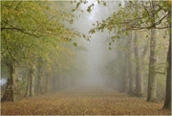

Fig(4.3.1). Input image

In this they are resized so that the maximum width and height is 500 pixels and their dark channels are computed using a patch size 15*X* 15.This focuses on enhancing the visibility of the image. For a patch with uniform transmission t, because the visibility (sum of gradient) of the input image is reduced by the haze.

**4.3.2 Dehaze:**

The value of the omega,win_size and the lambda values are checked for existence if the values are not set the values are set and call to the following function along with respective parameters are sent form these part of the code.

**4.3.3. Dark Channel:**

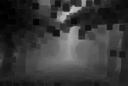

Fig(4.3.3).Result of Dark Channel

The basis for the paper and for using the dark channel prior is the observation that in most of the non-sky patches, at least one color channel has a very low intensity at some pixels. The dark channel, JDark is computed in darkChannel.m, which takes the (double, normalized) image produced by readIm as its input.  
For every 15x15 patch in the image, centered at pixel **x**, the dark channel at **x** is defined as the minimum value for all the channels and all the pixels in that patch.   
(In the dark channel image, white pixels have values close to 1 and black pixels have values close to 0.)

**4.3.4 Atmosphere:**

Although the authors talk about this later in the paper, estimating the atmospheric light is essential for section 4.3.5. To get the atmospheric light, we use the average of the pixels in the original image that correspond to the top lightest .01% in the dark channel. Thus, **A** has 3 elements, the average values for each color channel.

**4.3.5. Transmission estimation**

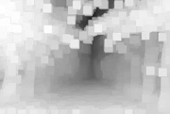 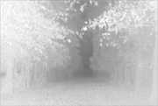

**4.3.5(a) Transmission 4.3.5(b)Redefined transmission**

**Fig(4.3.5). Results of Transmission Estimation**

Given **A** as calculated above, and assuming that the transmission in a local patch is constant, we can estimate the transmission. In this we used a value omega (=0.95) for how much haze to keep in the image in order to not remove the human ability to perceive depth. They define the transmission value as 1 - omega * the dark channel of the normalized haze image. We compute the normalized haze image as the channel-by-channel division of each element by the corresponding channel of **A** and then call the darkChannel function on the result.

**4.3.6.Laplacian**

From the initial transmission calculated in the previous section, we calculate a refined transmission map using image matting. The refined map is calculated by constructing a 'Matting Laplacian' (L) matrix and solving the following sparse linear system: (L+aU) t = at' where ‘a’is a constant, t is the refined transmission map, and t' is the original transmission map. To construct the 'Matting Laplacian' matrix, we loop over all possible 3x3 windows in the image. For each window, we calculate the mean RGB and RGB covariance. We then loop over all pairs of pixels in the window and fill out the Matting Laplacian matrix. Once L is constructed, we then solve the linear system and obtain our refined map. We used a value of lambda of 10^-4 (like in the Haze Removal paper) and a value of epsilon of 10^-8 (like in the Image Matting paper).

**4.3.7. Radiance**

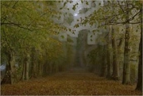 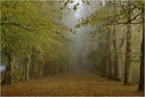

**4.3.7(a).Radiance 4.3.7(b).Redefined Transmission**

**Fig(4.3.7).Results of Radiance.**

Once we have the transmission map *t* and the atmospheric light **A**, we can use equation **[1]** to recover the scene radiance **J**. In order to avoid a noisy recovered scene radiance, we set a lower bound, t0 on *t*.

The final scene radiance is recovered using the getRadiance.m function. For every pixel in

**J(x)= A + (I(x)- A/max(*t*(x),t0)). [Equation 2]**   
 The exposure of **J**(**x**) was increased in the paper, but our preliminary results didn't indicate the need to do that. The final results are indeed darker than the original image, but it takes at least 5 hours to re-run the code, so we ended up leaving the original results. This is an easy fix.

**CHAPTER 5**

**RESULTS AND ANALYSIS**

In our experiments, we perform the local min operator using algorithm whose complexity is linear to image size. The patch size is set to 15 × 15 for a 600 × 400 image. In the soft matting, we use Jean Paul Gaultier Miscellaneous (jpg) algorithm as our solver. It takes about 1-3 minutes to process a 600×400 pixel image on a PC with a 2.40 GHz Intel core i5Processor.

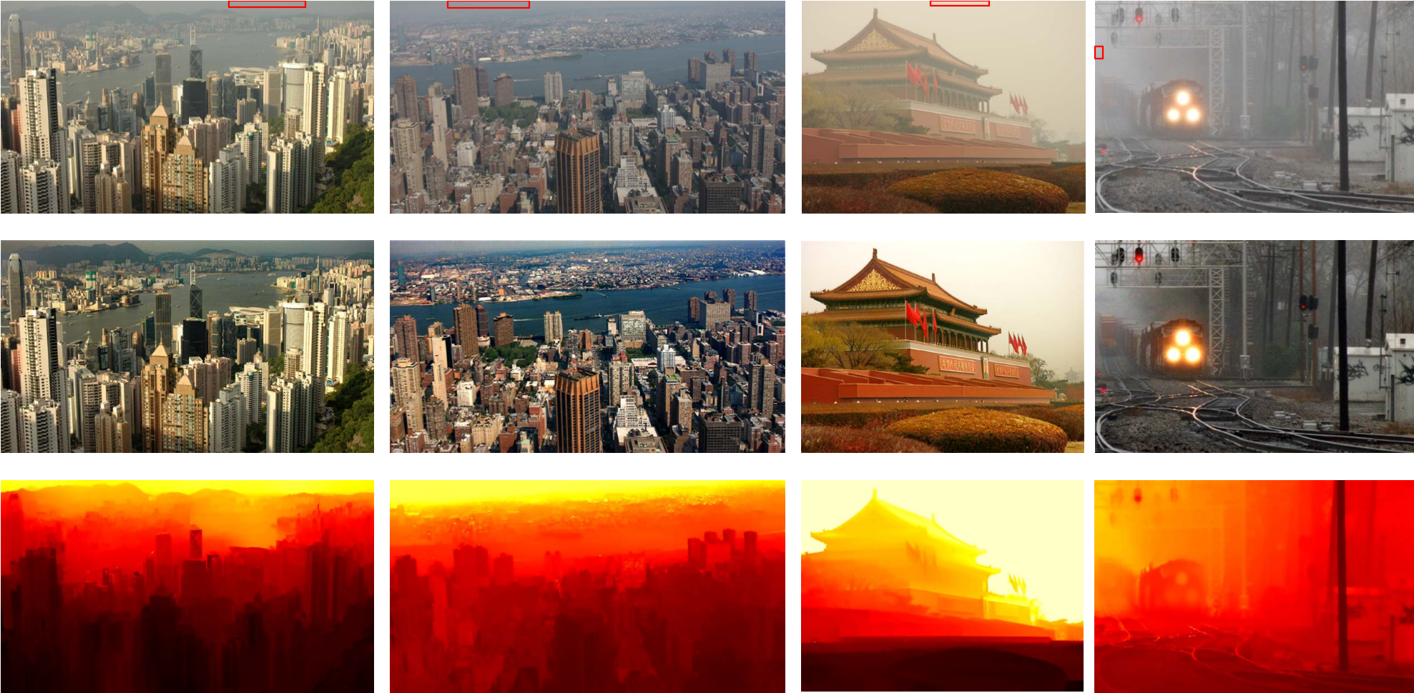

Fig (1) fig (2) fig (3) fig (4)

**Fig (5.1) Comparable Results**

Fig 1, 2, 3, 4 show our haze removal results and the recovered images. The depth maps are computed and are up to an unknown scaling parameter *β*. The atmospheric lights in these images are automatically estimated using the method described dark channel. As can be seen, our approach can unveil the details and recover vivid color information even in very dense haze regions. The estimated radiances values are sharp and consistent with the input images.

Figure 5.2

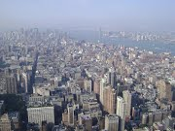

Fig. 5.2.1. Original image

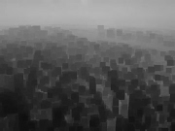

Fig.5.2.2.Dark Channel prior

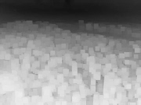

Fig.5.2.3.Transmission.

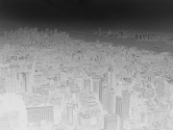

Fig.5.2.4.Redefined Transmission.

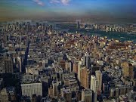

Fig.5.2.5.Radiance

Fig.5.2.6.Refined Radiance

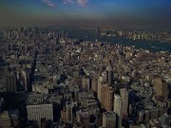

**CHAPTER 6**

**CONCLUSION**

In our project we have presented a very simple but powerful prior, called dark channel prior, for single image haze removal. The dark channel prior is based on the statistics of the outdoor images. Applying the prior into the haze imaging model, single image haze removal becomes simpler and more effective. New method for estimating the transmission in hazy scenes based on minimal input, a single image is used.

This new approach is physically sound and relies only on the assumption that the transmission and surface shading are locally uncorrelated. By means of the depth map obtained by the proposed method, the scene radiance of the hazy image can be recovered easily. In its essence this method solves a non-linear inverse problem and therefore its performance greatly depends on the quality of the in-put data.

A single image dehazing method which improves color distortions that are sometimes observed in the conventional dark channel prior method. The color distortion usually appears on the objects which have similar colors to the atmospheric light. Result show that the proposed method yields more plausible transmission map and thus the results have less color distortion.

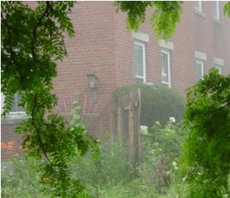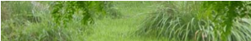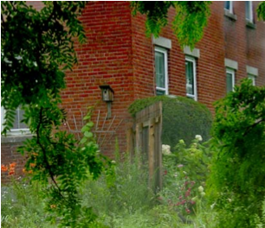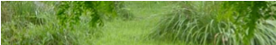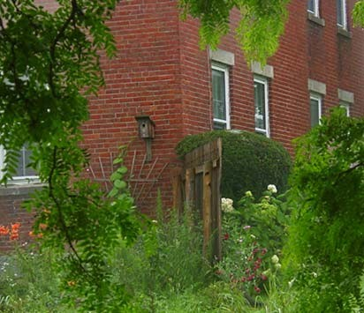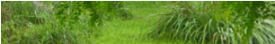

fig(5.2.1) fig(5.2.2) fig(5.2.3)

**fig (5.2) comparison with Fattal’s work**

Next, we compare our approach result with Fattal’s work. In Fig 5.2, our result is comparable to Fattal’s result.

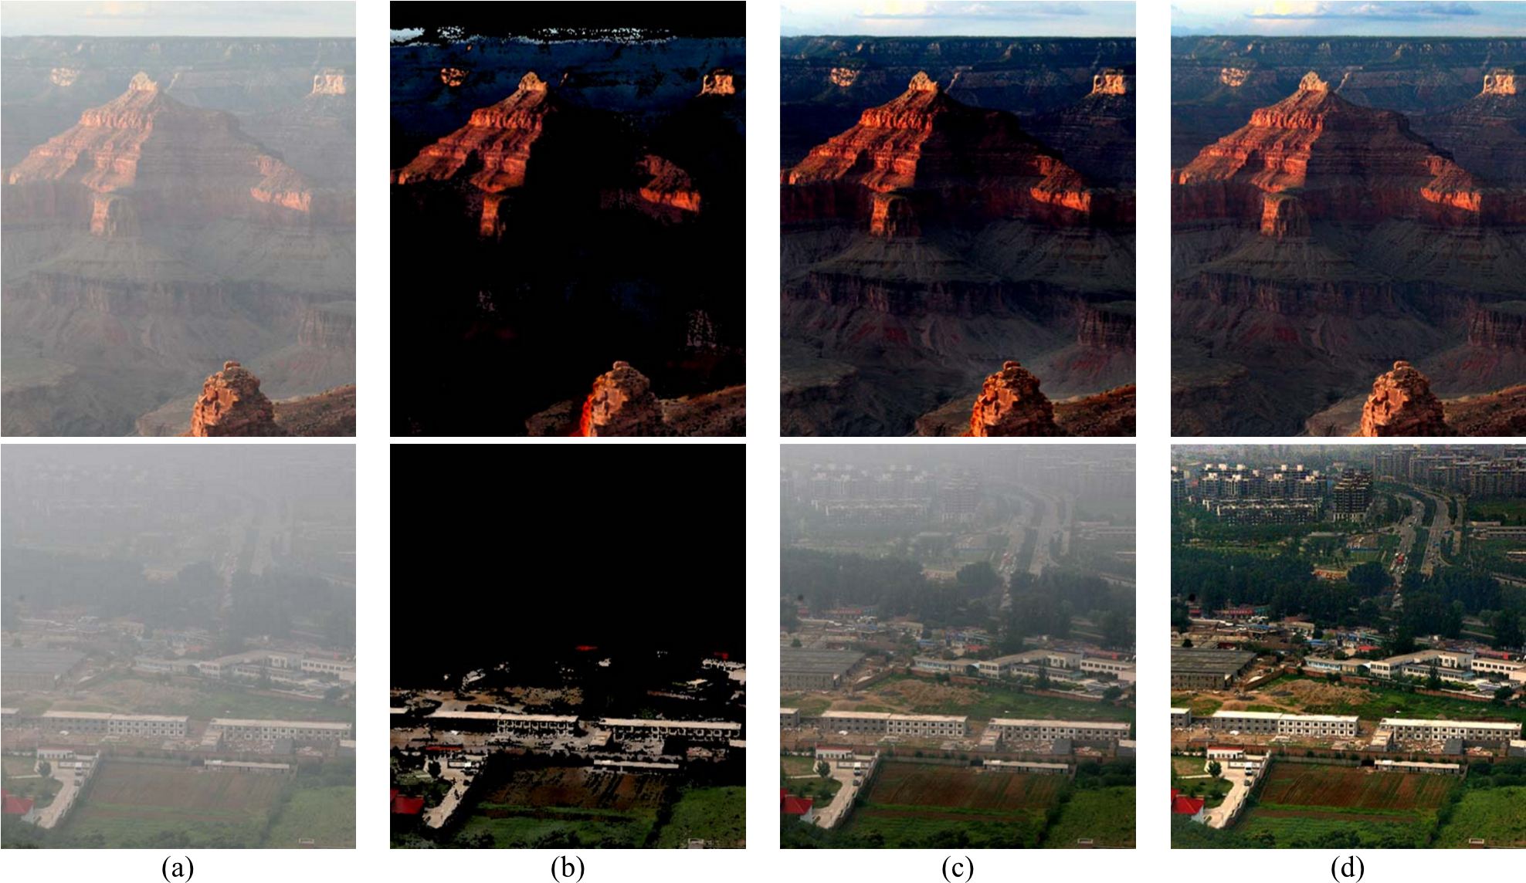

**Fig(5.2.3). More comparisons with Fattal’s work . (a) Input images. (b) Results before extrapolation, using Fattal’s method. The transmission is not estimated in the black regions. (c) Fattal’s results after extrapolation. (d) Our results.**

In Figure (5.2.3), we show that our approach outperforms Fattal’s in situations of dense haze. Fattal’s method is based on statistics and requires sufficient color information and variance. If the haze is dense, the color is faint and the variance is not high enough for his method to reliably estimate the transmission. Figure (5.2.3) (b) and (c) show his results be- fore and after the MRF extrapolation. Since only parts of transmission can be reliably recovered, even after extrapolation, some of these regions are too dark (mountains) and some hazes are not removed (distant part of the cityscape). On the contrary, our approach works well for both regions (Fig 5.2.3(d)).

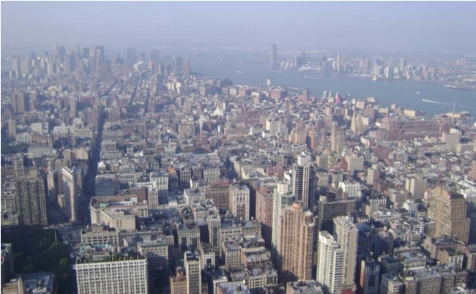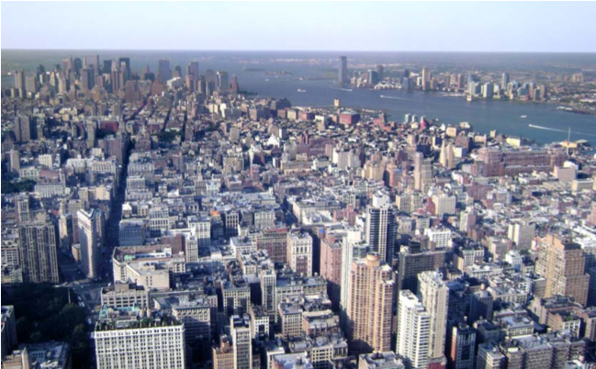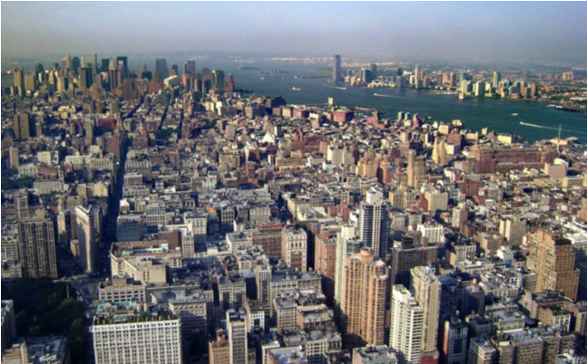

**Fig(5.2.4) compare our method with L. Kratz: input image. Middle: kartz’s result. Right: our result**

We also compare our method with kratz.’s very recent work [4] in Figure (5.2.4). To remove the haze, they utilize the 3D models and texture maps of the scene. This additional information may come from Google Earth and satellite images. However, our technique can generate comparable results from a single image without any geometric information.

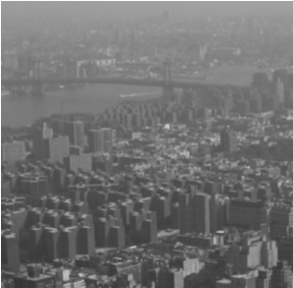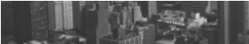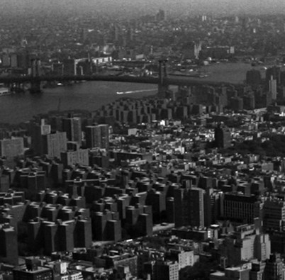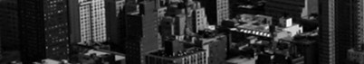

Figure 5.2.5 Gray-scale image example.

Our approach even works for the gray-scale images if there are enough shadow regions in the image. We omit the operator min*c* and use the gray-scale form of soft matting. Figure 5.2.5 shows an example.

**FUTURE WORK**

 The transmission map to the scattering coefficient of the atmosphere as well as the scene depth. Since we've already calculated a refined transmission map, we would also be able to calculate a depth mapping for each image. Unfortunately, due to time constraints, we were unable to accomplish this.

In the refinement of the transmission map, we constructed the Matting Laplacian matrix and used Matlab's linear solver which in total resulted in very long processing time, even for small images. The Preconditioned Conjugate Gradient algorithm as a solver, allowing them to process a 600x400 pixel image in roughly 10-20 seconds.

**REFERENCES**

[1] S. K. Nayar and S.G. Narasimhan, “Vision in bad weather,” *IEEE Int’l Conf. on Computer Vision and Pattern Recognition* (CVPR), vol. 2, pp. 820–827, 1999.

[2] R. Fattal, “Single image dehazingr,” *ACM SIGGRAPH*, pp. 1956–1963, 2008.

[3] R.T. Tan, “Visibility in bad weather from a single image,” *IEEE*

*Computer Vision and Pattern Recognition* (CVPR), pp. 1–8, 2008.

[4] L. Kratz and K. Nishino, “Factorizing scene albedo and depth from a single foggy image,” *IEEE Int’l Conf. on Computer Vision* (ICCV), pp.

1701–1708, 2009.

[5] Qieshi Zhang and Sei-ichiro Kamata “Improved Optical Model Based on Region Segmentation for Single Image Haze Removal ”IEEE *International Journal of Information and Electronics Engineering, Vol. 2, No. 1, January 2012*

[6] E. Hsu, T. Mertens, S. Paris, S. Avidan, and F. Durand. Light mixture estimation for spatially varying white balance. In *SIGGRAPH*, pages 1–7, 2008. 5

[7] J. Kopf, B. Neubert, B. Chen, M. Cohen, D. Cohen-Or, O. Deussen, M. Uyttendaele, and D. Lischinski. Deep photo: Model-based photograph enhancement and viewing. *SIGGRAPH Asia*, 2008. 1, 7, 8

[8] H. Koschmieder. Theorie der horizontalen sichtweite. *Beitr. Phys. Freien Atm.*, 12:171–181, 1924. 1, 2

[9] A. Levin, D. Lischinski, and Y. Weiss. A closed form solution to natural image matting. *CVPR*, 1:61–68, 2006. 4, 5, 7

[10] S. G. Narasimhan and S. K. Nayar. Chromatic framework for vision in bad weather. *CVPR*, pages 598–605, 2000. 1, 2